
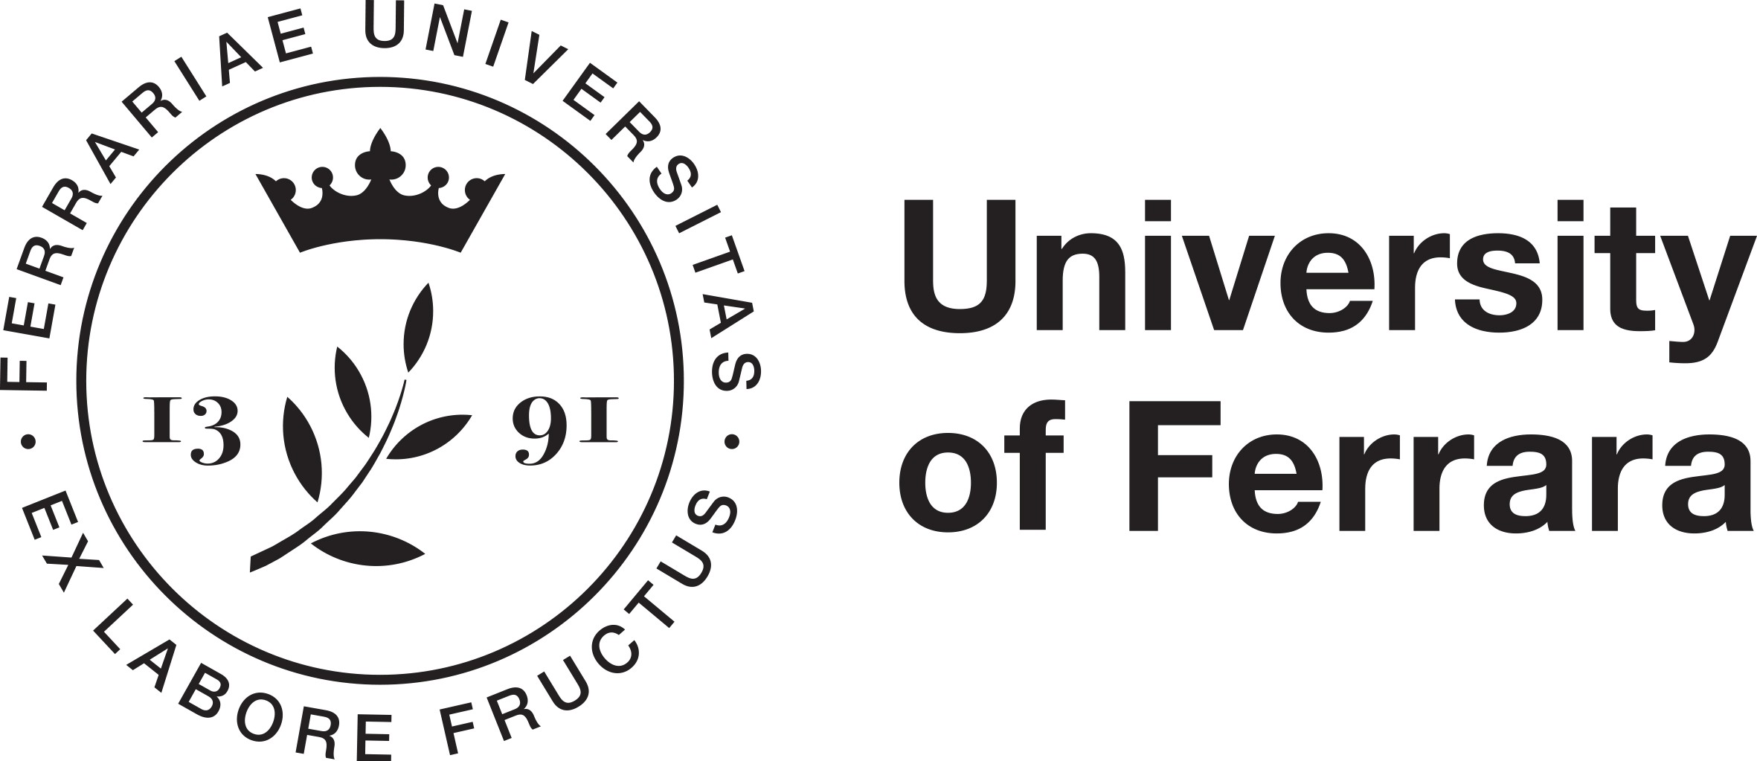

Safeguarding
the Human Person
in an Age of
Artificial Intelligence

14 September 2026, 11:00 am – 5:30 pm
University of Ferrara
Rectorate
Auditorium Santa Lucia
Via Ariosto 35, 44121 Ferrara
And Online at: http://meet.google.com/jqb-maff-cqi

Scientific Committee

Alberto De Franceschi (University of Ferrara) and Frank Pasquale (Cornell University)

Information and Registration: alberto.defranceschi@unife.it

This public symposium is designed to bring together leading thinkers in computer science, psychology, neuropsichology and cognitive neuroscience, medicine, philosophy, and law in order to promote mutual understanding and preserve human values in the age of AI. The three panels and keynote will focus on different dimensions of the use of AI and its potential improvement.
In recent times, documents ranging from warning statements by founders of tech
companies and AI company employees, to the Vatican's encyclical Magnifica Humanitas, have highlighted the dangers and opportunities of AI use. At this event, we plan to share ideas about what is most urgently needed on the regulatory agenda, bearing in mind both cutting-edge technological developments and the eternal verities of philosophical perspectives.

11:00 – Introduction
Klaus Mainzer, Technical University of Munich, President of the European Academy
of Sciences and Arts
Frank Pasquale, Cornell University, Ithaca / New York
Alberto De Franceschi, University of Ferrara, Dean of Class V of the European Academy
of Sciences and Arts

11:15 – I. The Permanent Value of the Human in an Age of Technological Upheaval
Chair: Valerio Capraro, Bicocca University, Milan
Marta Infantino, University of Trieste
Walter Quattrociocchi, Sapienza University, Rome
Andrea Simoncini, University of Florence
Xin Shi, China Medical University
Antonio Albanese, Catholic University of the Sacred Heart, Milan

12:30: Light Lunch

13:45 – II. Public Regulation of AI to Promote Universal Values: Social, Economic and Environmental Sustainability of Artificial Intelligence
Chair: Frank Pasquale, Cornell University, Ithaca / New York
Klaus Mainzer, Technical University of Munich, President of the European Academy
of Sciences and Arts
Gry Hasselbalch, Dataethics.eu
Andrea Favaro, University of Verona
Giovanni Sartor, University of Bologna / European University Institute
Paolo Passaglia, University of Pisa

15:00: Break

15:15 – III. Private Regulation of AI to Preserve Labor, Rights, Privacy, and Consumer Protection
Chair: Giovanni Sartor, University of Bologna / European University Institute
Gianclaudio Malgieri, University of Maastricht
Hans-Wolfgang Micklitz, European University Institute
Geraint Howells, University of Galway
Camilla Crea, University of Sannio
Alberto De Franceschi, University of Ferrara

16:30: Break

16:45 – Keynote Concluding Lecture
Valerio Capraro, Bicocca University, Milan

