*

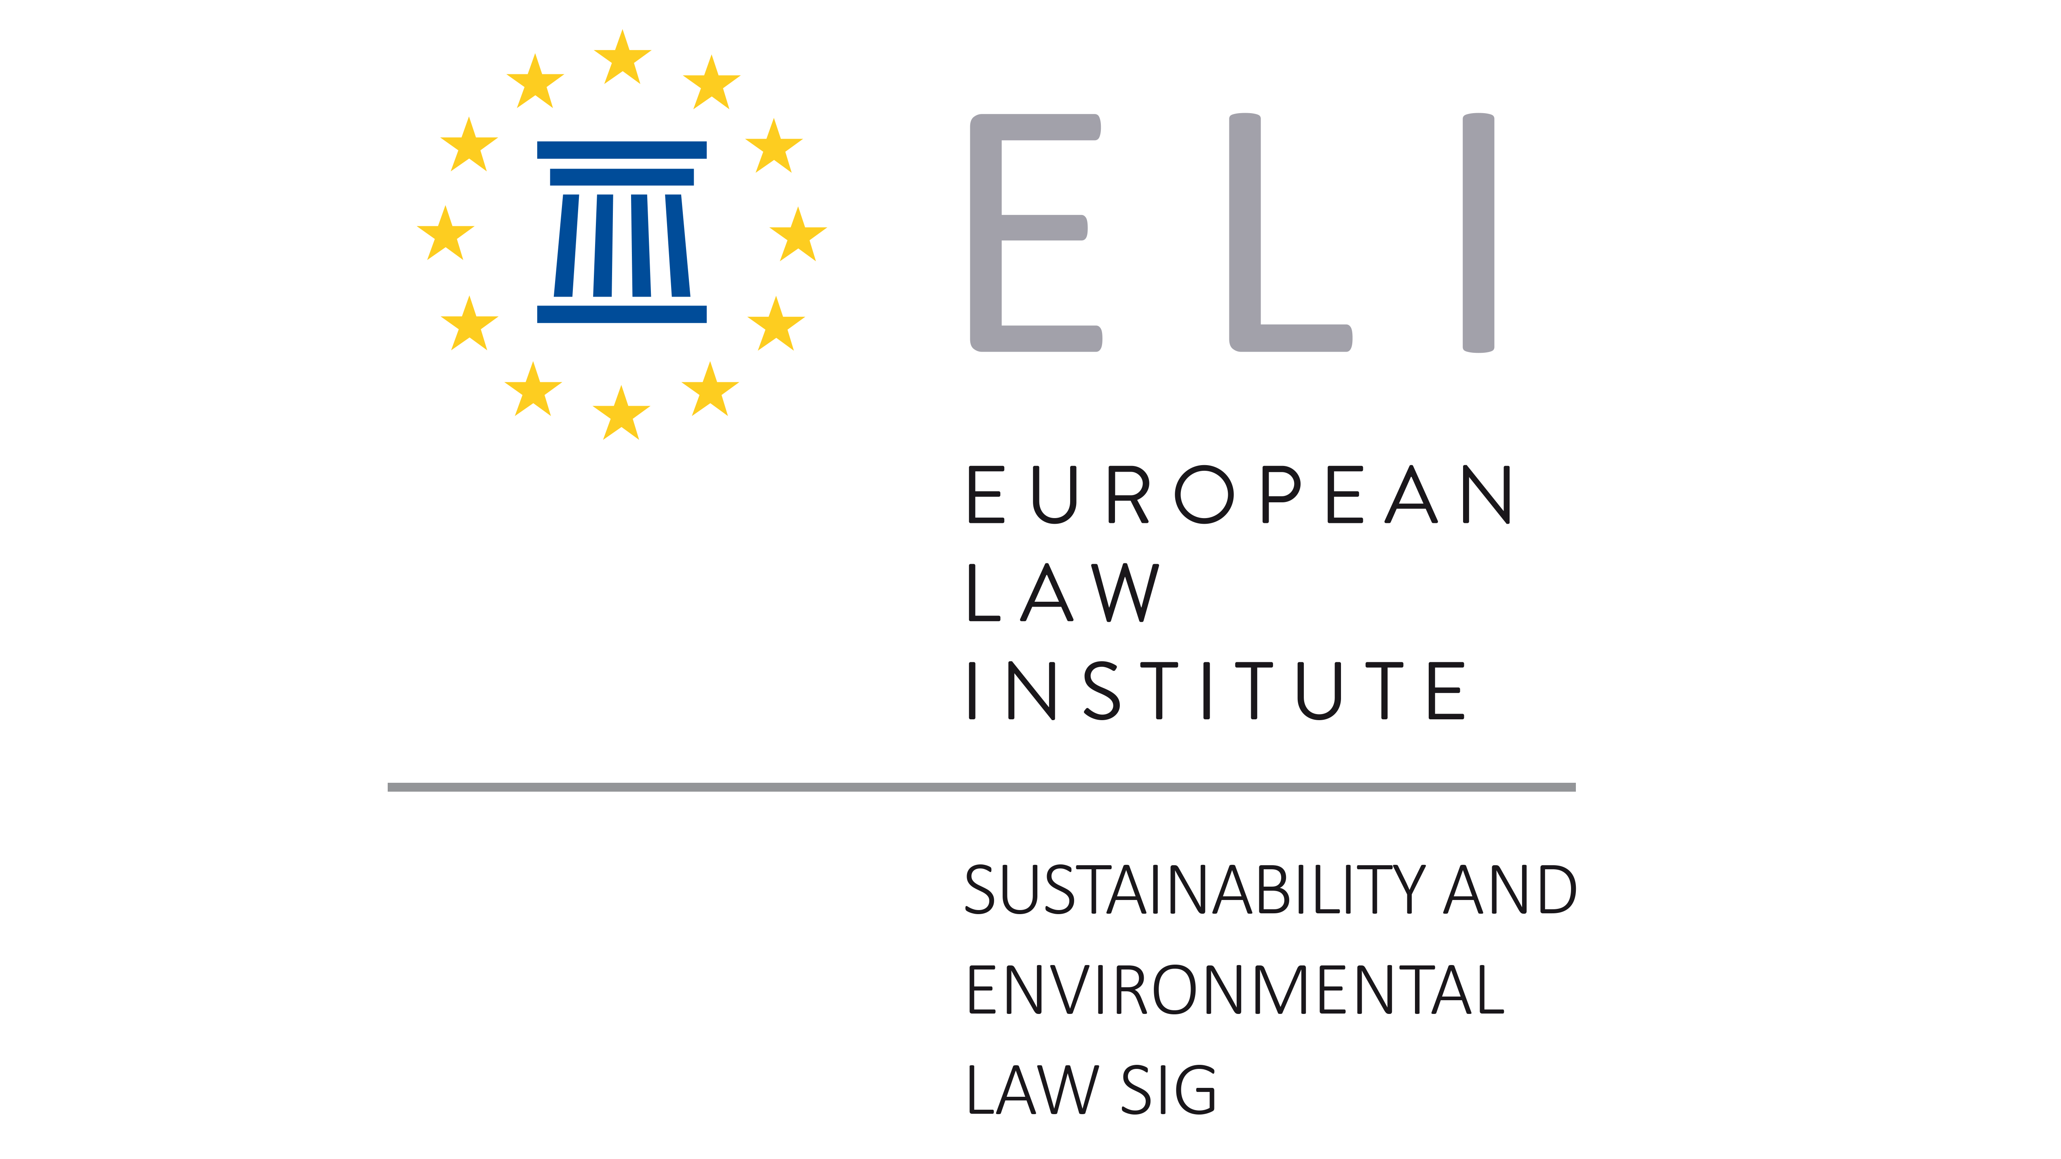

**Global Conference on**

**AI for Sustainability &**

**Sustainability of AI**

**23 May 2025**

**Katholieke Universiteit Leuven, Faculty of Law and Criminology**

**DV1 91.56 Auditorium Zeger Van Hee**

**Tiensestraat 41, Leuven**

**and Online**

**Scientific Committee:**

**Alberto De Franceschi, Bert Keirsbilck, Evelyne Terryn**

Participation is Free of Charge but in Advance Registration is Mandatory

Should you Wish to Participate, Please Register [here](https://www.law.kuleuven.be/apps/activiteiten/activities/global-conference-on-ai-for-sustainability-sustainability-of-ai-6543#6543)

**09:00 - Introduction**

*Bert Keirsbilck (KU Leuven)*

*Evelyne Terryn (KU Leuven)*

*Massimiliano Mazzanti (University of Ferrara)*

**09:30 I. AI for Sustainability: The Global Framework**

Chair:*Alberto De Franceschi (University of Ferrara / KU Leuven)*

**Hypergrowth, Degrowth, and Different Growth: Three Scenarios for AI and Sustainability**

*Frank Pasquale (Cornell Tech, New York and Cornell Law School, Ithaca)*

# **Green AI**

*Heng Wang (Singapore Management University)*

**10:30 Discussion**

**11:00 Coffee Break**

**11:30 II. AI for Sustainability: Political Landscape and The Role of Data Centers**

*Chair: Bert Keirsbilck (KU Leuven)*

**Environmental Ethics of AI**

*Lode Lauwaert (KU Leuven)*

**EU Political Landscape for AI and Sustainability – Challenges and Opportunities to Strengthen Europe’s Competitiveness**

*Ornella Cosomati-Koschwitz (Director of Europe Energy & Sustainability Policy - Global*

*Environmental Sustainability Team at Microsoft)*

**The Role of Data Centers for a Sustainable AI**

***Sherif Rizkalla*** *(President of the Italian Datacenter Association, Milan)*

**12:30 Discussion**

**13:00 Lunch**

**14:00 III. The Sustainability of AI**

Chair: *Frank Pasquale (Cornell Tech, New York and Cornell Law School, Ithaca)*

**Sustainable AI Regulation**

*Philipp Hacker (European University Viadrina, Frankfurt an der Oder)*

**AI, Climate, and Regulation: From Data Centers to the AI Act**

*Kai Ebert (European University Viadrina, Frankfurt an der Oder)*

**AI, Environment and a Call for Due Diligence**

*Jason Rudall (University of Leiden)*

**15:00 Discussion**

**15:30 Coffee Break**

**16:00 IV. Round Table**

Chair:*Evelyne Terryn (KU Leuven)*

*Martin Ulbrich (European Commission – DG Connect)*

*Vilma Kaza (*EU Sustainability and Energy Policy Lead at Google, *Brussels)*

*Karolina Telejko (Director Sustainability and Government Affairs at SAP, Brussels)*

*Andrea Giordano (Court of Auditors, Rome and Head of the Italian Legislative Office at the*

*Ministry of Health)*

*Paolo Cassinis (Competition and Market Authority, Rome)*

*Oreste Pollicino (Bocconi University, Milan)*

**18:00 Conclusions**